AGU Word Manuscript Template

**Please us this template and for submitting a new or revised manuscript to any AGU journal.** Using this template and following the guidelines below, will help us expedite processing of your paper and its formatting for initial publication once it can be accepted.

Please use the actual template, which starts on page 2. Delete this cover page.

Helpful links:

Journal submission sites: <http://publications.agu.org/author-resource-center/submissions/gems-submission-sites/>

Additional instructions are available at <http://publications.agu.org/author-resource-center/>

Please follow our [checklists](https://publications.agu.org/author-resource-center/checklists-and-templates/) for initial submission or revision**. Resubmissions that were previously reviewed should follow the “revision” checklist.**

AGU has [implemented](https://eos.org/editors-vox/new-style-for-agu-journals-and-books) new styles. These mostly affect formatting of references, which are now cited in parentheses, not brackets. See [here](https://publications.agu.org/agu-grammar-and-style-guide/) for details.

**Length**: Research Articles in most AGU journals have an allowed length of 25 publication units. Letters in *Geophysical Research Letters (GRL)* and Technical Reports on Data or Methods in *Earth and Space Science* have an allowed length of 12 publication units (1 unit = 500 words or 1 table or figure; excluded from the word count are title, plain language summary, author lists, references, and all supplements). AGU encourages research publications that are thorough but also concisely presented. This benefits readers as well as reviewers, who are increasingly taxed. Editorial and production costs also scale with length. However, all AGU journals except *GRL* allow longer papers beyond these guidelines for an additional fee ([**see table**](https://publications.agu.org/files/2017/02/pubfeetable.pdf)) that reflects these incentives. ***Submissions to GRL that are longer than the allowed length of 12 Publication Units will be returned immediately for shortening.*** Some journals have publication [fees](https://publications.agu.org/author-resource-center/publication-fees/). [Open access](http://publications.agu.org/open-access/) is available in all AGU journals.

Please use the .docx format if possible (all versions of Word after 2007). This document contains pre-set styles that apply to each manuscript element. These styles are listed below. Please keep these styles by pasting in your text when done and matching, or applying these styles in your document using the style pane or organizer.

Title

Authors

Affiliation

Key points

Abstract

Plain Language Summary

Text

Headings (Main and secondary)

Figure or Table Captions

References

Please use our separate template for supporting information <http://publications.agu.org/author-resource-center/text-requirements/#supmat>

More specific formatting instructions are provided in the actual template, which follows. Delete these instructions from your finished manuscript.

AGU requires the corresponding author and encourages all authors to register for an [ORCID](http://orchid.org); we will upload published contributions and reviews to your profile. Each author can easily create or link your ORCID in GEMS.

Influence of a western boundary current on cross shelf patterns in zooplankton

(A title should be specific, informative, and brief. Capitalize major words in titles, but not conjunctions and articles. Use abbreviations only if they are defined in the abstract. Titles that start with general terms then specific results are optimized in searches—delete these notes when done)

**Hayden T. Schilling1,2, Amandine Schaeffer3, Jason D. Everett2, Mark Baird4, Peter Yates1,2, Iain M. Suthers1,2**

1Sydney Institute of Marine Science, Chowder Bay Road, Mosman, New South Wales, Australia

2Centre for Marine Science & Innovation, University of New South Wales, High Street, Kensington, New South Wales, Australia

3School of Mathematics and Statistics, University of New South Wales, High Street, Kensington, New South Wales, Australia

4Commonwealth Scientific and Industrial Research Organisation, Castray Esplanade, Battery Point, Tasmania, Australia

(Affiliations should be preceded by superscript numbers corresponding to the author list. Each affiliation should be run in so that the full affiliation list is a single paragraph.)

Corresponding author: Hayden T. Schilling ([Hayden.Schilling@sims.org.au](mailto:Hayden.Schilling@sims.org.au))

Key Points:

* List up to three key points (at least one is required)
* Key Points summarize the main points and conclusions of the article
* Each must be 140 characters or less with no special characters or acronyms.

(The above elements should be on a title page)

Abstract

Western boundary currents are known to influence continental shelf waters through a variety of physical mechanisms. Despite this, understanding of how western boundary currents influence the biota on the continental shelf is limited. Zooplankton are the basis for many ecosystems on the continental shelf yet it is largely unknown how the east Australian current influences the coastal waters and the zooplankton they contain. By combining 4 targeted cross-shelf transects from inshore to off the continent shelf in Australia with an analysis of satellite derived sea surface temperature, we show that there is a regularly occurring EAC driven inshore – offshore temperature gradient on the continental shelf of eastern Australia which corresponds to changes in the zooplankton community. Zooplankton biomass, abundance and geometric mean size generally declined with increasing distance from the coast and depth when the EAC was influencing the coastal water on the continental shelf through uplift of cooler nutrient rich water. This cooler water also had a steeper normalized biomass size spectrum slope, signifying that this is highly productive water. This highly productive band of inner shelf water may be contributing the consistently high yield from fisheries in this region. This influence of the EAC on continental shelf zooplankton is likely reflected in other western boundary current regions where the fast flowing currents influence water on the continental shelf though uplift of colder water.

The abstract should be a single-paragraph of less than 250 words, or for *Geophysical Research Letters*, less than 150 words. A good abstract sets the general question or topic that you are studying for the general reader, provides background on the specific question or problem, briefly describes key data or analyses, and describes the key results and uncertainties. Please avoid acronyms or if used, define them.

**Plain Language Summary**

This is optional but will help expand the reach of your paper. Information on writing a good plain language summary is available [here](http://sharingscience.agu.org/creating-plain-language-summary/).

1 Introduction

Western boundary currents (WBCs) are fast-flowing currents which transport warm salty water from low latitudes poleward. As they flow along continental boundaries they generally inhibit cross-shelf transport due to their strong along shore flows (*Roughan et al.*, 2011). At a more local scale, WBCs interact with the continental shelfs to generate eddies, fronts and upwelling. These features increase mixing across the continental shelf (Malan et al *In Press*). By increasing mixing and upwelling on the continental shelf, WBCs are contributing to production through the supply of nutrients normally found in the cooler deeper water (*Pereira Brandini et al.*, 2014).

Within upwelling dominated systems such as western boundary currents, zooplankton have been shown to have important keystone roles (*Libralato et al.*, 2006). This role includes transferring energy to fish (*Champion et al.*, 2015; *Marquis et al.*, 2011) as well as linking the benthic and pelagic zones. It has been estimated that zooplankton support up to 53 % of fish biomass on temperate coastal reefs (*Truong et al.*, 2017).

Size is an important trait in pelagic systems with predator-prey interactions usually driven by size (*Barnes et al.*, 2010). By focusing on the size distribution of the zooplankton community complex species specific dynamics can often be simplified. One method of analyzing the size structure is through the normalized biomass size spectrum (*Kerr and Dickie*, 2001). Using a linear fit of normalized biomasses in logarithmically equal size bins, the structure of the zooplankton community can be quantified, with a general overall slope of -1 observed in the open sea (*Baird et al.*, 2008). A steeper slope with large amounts of small particles generally infers higher production while a shallow slope often represents lower predation and less ‘top-down’ pressure (*Blanchard et al.*, 2017).

The distribution of zooplankton is the result of a number of factors including physical mechanism such as transport and retention, biological factors including prey availability and predator abundance as well as behavior of the zooplankton (*Huntley et al.*, 2000). It has previously been observed that zooplankton are not distributed uniformly across continental shelf with oceanographic features a key factor in these distributions. In the southeast Atlantic it was shown that the zooplankton community on the continental shelf had higher biomass and a steeper NBSS slope compared to the offshore oceanic stations which were typically more vertically stratified (*C d R Marcolin et al.*, 2013). This is similar to other studies in the northeast Atlantic where high zooplankton biomasses and steeper NBSS were found in some but not all inshore regions with the majority of high productivity areas located along the French coastline with productivity and biomass decreasing in offshore areas (*Irigoien et al.*, 2008; *Sourisseau and Carlotti*, 2006; *Vandromme et al.*, 2014). This onshore-offshore gradient in biomass has also been observed in the southwest Atlantic where it was identified that vertical distributions of zooplankton on the continental shelf are likely related to water masses (*Pereira Brandini et al.*, 2014). Few studies have explicitly examined patterns of zooplankton with depth on continental shelfs. Off New York, during late summer it was observed that total zooplankton abundance was higher at depth close to the coast (< 50 m bathymetry) with smaller effects seen offshore (> 50 m bathymetry; *Turner and Dagg*, 1983). This is contracted by a winter study on the Abrolhos Bank where on the shelf, copepod abundance peaked near the surface (20 – 40m) and decreased with depth (*C Marcolin et al.*, 2015). On the other hand, light availability and predation by fish is thought to be a significant driver of zooplankton depth distributions in the Barents Sea (*Aarflot et al.*, 2019).

The East Australian Current (EAC) is a baroclinic jet which forms between 10 and 20 °S when the South Equatorial Current diverges against the Australian coast. It flows south at approximately x – x m s-1 flowing the continental shelf until the majority of the EAC separates from the coast at approximately 30 – 32 °S and continues to flow eastward as the EAC eastern extension (*Cetina-Heredia et al.*, 2014; *Oke et al.*, 2019). The remaining portion of the EAC continues to flow south along the coast as part of the EAC southern extension generating a large eddy field. Along the continental shelf, particularly in the where the continental shelf narrows, the EAC had significant impact on shelf circulation. Current driven bottom friction leads to Ekman transport in the bottom boundary layer, moving cooler denser water up the slope, resulting in uplift of isotherms and upwelling. These upwelling events have been shown to bring nutrient rich water into the euphotic zone, increasing primary productivity (*Rossi et al.*, 2014) and controlling vertical phytoplankton abundance, composition and distribution (*Linda H. Armbrecht et al.*, 2014; *L. H. Armbrecht et al.*, 2015). Phytoplankton and nutrients are a key energy source for zooplankton and it is highly likely that the variable EAC is influencing zooplankton communities similar to the phytoplankton communities. Despite this there is little information on how western boundary currents influence depth stratified patterns of zooplankton on the continental shelf around the world and no analyses in the EAC continental shelf region. This study therefore aims to investigate cross shelf and depth stratified patterns of zooplankton on the east Australian continental shelf and identify the temporal stability of any observed patterns.

2. Materials and Methods

2.1 Voyage details

The cruise took place at the beginning of the austral spring, in September 2004 on the *RV Southern Surveyor*. At this time, the EAC had separated from the coast at approximately 31°S and formed a large pool of water at 33°S, 155°E, creating a counter-clockwise rotating warm core eddy (Fig 1).

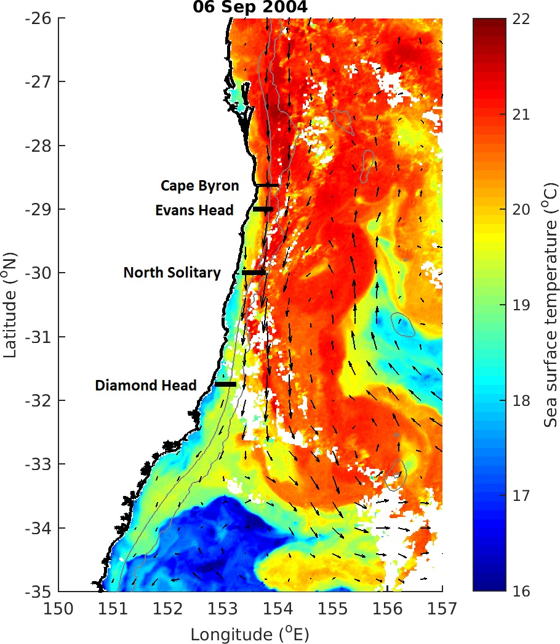

Figure 1. Locations of the 4 cross shelf sections which were sampled in September 2004. The sea-surface temperature for 6th September 2004 is shown in colour with velocity arrows shown with black arrows.

2.2 Sampling

Five sections were sampled along constant latitude transects roughly perpendicular to the north NSW coast over a 6 day period in September 2004. 4 of these sections used a CTD and 4 sections used a towed device called the Bunyip (a highly modified SeaSoar) with 3 sections using both the CTD and Bunyip. During the CTD transects, florescence, temperature, salinity and oxygen were electronically measured, and nutrients (NO3, PO4, Si) and bottle oxygen taken at the surface, and, total depth of water allowing, at depths of 25, 50, 75, 100, 150, 200, 250, 400 and 500 m. Filtered particulate matter samples were taken at the surface of each of the CTD stations. The Bunyip was towed from inshore to offshore and varied between the 10 and 120 m, sampling temperature, salinity, and, using an optical plankton counter (OPC; *Herman*, 1992), the size distribution of particulate matter. The ship was also equip with an ADCP which continuous monitored the velocity of water beneath the vessel. This paper will focus on the four sections which were analysed with the OPC. Further sampling during this period using towed plankton nets will be reported in later publications. The shelf sampling was interrupted on the 8-10th September to undertake a wake study around North Solitary Island (29°55'S 153°23'E) which will be reported elsewhere. All times reported are local (Sydney) Australian eastern Standard Time.

2.2.1 Sections

The 4 sections which were analysed using the OPC were as follows:

Diamond Head Section (31°45'S). The Bunyip undertook a transect between 1953-2201 on the 6th September in an easterly direction, followed by net tows in a westward direction. A CTD transect was then undertaken in an easterly direction on the 7th September from 0437-0838.

North Solitary Island Section (30°00'S). The Bunyip undertook a transect between 2134 on the 7th September and 0013 on the 8th in an easterly direction, followed by net tows in a westward direction. A CTD transect was then undertaken in an easterly direction on the 8th September from 1340 -2314.

Evans Head Section (29°00'S). A Bunyip transect was undertaken in an easterly direction from 1048-1243 on the 11th September. A CTD transect followed in a westward direction from 1317-2044 on the 11th September, and finally net tows.

Cape Byron Section (28°38'S). A Bunyip transect was undertaken in an easterly direction from 0805-1006 on the 12th September. No other sampling was undertaken at Cape Byron.

2.3 Chlorophyll analysis (IS THIS NEEDED?)

Water sampled for Chl a analysis was filtered through a 47 mm diameter, 1.2 µm glass fibre filter under low vacuum within 30 minutes of collection. Filters were then folded, blotted dry, wrapped in aluminium foil and stored at -20°C until analysis. Chl a concentration was calculated using the method of Jeffery and Humphrey (1975). The calibration curve of the CTD fluorometers is shown in Fig. 2 of Baird et al. (in prep.), where Fl = 4.66 [Chl a] +52.66, r2 = 0.73. Chl a is converted to phytoplankton biomass using 1 mmol N = 1.59 mg Chl a (Fasham et al., 1990).

2.4 Optical plankton counter

The OPC was mounted on the Bunyip, a CSIRO customised towed device. The OPC (OPC) is a Focal Technologies Corporation Model OPC-2T with a sampling aperture of 2 x 10 cm. The OPC records equivalent spherical diameters of particles that pass through the instrument in a 0.5 s interval. The particle sizes are recorded digitally into 4096 bins, corresponding within the operating range of the instrument to bins with a 5 and 15 µm width. (not sure here?)

The volume of flow through the sample region is based on distance measured, averaged over a 6 s interval. The choice of time interval is a trade-off between a larger time period to obtain a higher particle count to accurately obtain the estimate of the size distribution, and a shorter time period to provide better spatial resolution. The spatial averaging is along the instrument trajectory. As the instrument moves vertically at approximately 1 m s-1, a long period averaging most affects vertical resolution. A 6 s interval provides the best resolution of spatial distribution of size distribution of the Tasman Sea waters with a biomass of ≈ 1-10 mmol N m-3.

3 Data, or a descriptive heading about data

Satellite Data (From Iain’s Paper – needs rewording)

MODIS Level 3 sea surface temperature and ocean-colour data (chlorophyll-a) were obtained from the Integrated Marine Observing System (IMOS) Data Portal (<http://imos.aodn.org.au/imos/>) at 1 km resolution. Chlorophyll-a was derived using the OC3 algorithm. MODIS data were retrieved for 5x5 pixels (~25 km2) surrounding the centre of each sample, on the day of sampling. Satellite altimeter data for sea- surface height anomaly were obtained from NASA/CNES (Jason-1 and 2) and ESA (ENVISAT) and mapped in near-real time for the Australian region. Bathymetry data was sourced from GEBCO (*GEBCO Bathymetric Compilation Group*, 2019).

4 Results, or a descriptive heading about the results

Regional Oceanography Description (Does this go in the methods?)

During early September 2004, the EAC was flowing southward along the coast until approximately 31 °S where it separated from the mainland and continued flowing to the east. This separation resulted in the formation of a large anti-cyclonic warm-core eddy forming off the coast at approximately 33 °S, 155 °E (Figure 1). The three northern most sites had increasing velocity over previous month and all crossed from cool inshore waters into warm (21 °C) EAC water. This is contrasted by the Diamond Head transect which was located south of the separation zone in cooler (<19.5 °C) waters and did not cross into EAC waters. All transects showed low chlorophyll levels (<1.4 mg m-3) peaking at the surface which was representative of the previous month of low chorophyll at these locations. There was also with negligible wind effects in the 3 days prior to the transects.

**Cape Byron**

This transect was dominated by the EAC which had a strong southward flow (1.50 m s-1) centred over the 200 m isobath (27.6 km offshore). The EAC also showed slight onshore movement which increased offshore and with depth (up to 0.26 m s-1).

There was strong current driven uplift of the isotherms inshore of the EAC with the 21 °C isotherm rising to the surface from 70 m depth over 5 km and the 20 °C isotherm rising to the surface from 100m depth over 15 km.

**Evans Head**

This transect was dominated by the EAC which had a strong southward flow (1.47 m s-1) centred 36.1 km offshore (220 m bathymetry). The EAC had a slight offshore movement (0.27 m s-1) which increased with distance offshore.

There was strong current driven uplift of the isotherms inshore of the EAC with the 21 °C isotherm rising to the surface from 70m depth over 6 km and the 20 °C isotherm rising to the surface from 100m depth over 15 km.

**North Solitary**

This transect was dominated by the EAC which had a strong southward flow (1.59 m s-1) centred 37.7 km offshore (310 m bathymetry). The EAC showed slight onshore movement offshore and at depth (0.15 m s-1).

There was strong current driven uplift of the isotherms inshore of the EAC with the 21 °C isotherm rising to the surface from 70m depth over 3 km and the 20 °C isotherm rising to the surface from 100m depth over 10 km.

**Diamond Head**

The transect at this site did not cross into the EAC which had separated from the coast to the north. Within the transect the, along shore velocities are low (< 0.43 m s-1) with corresponding low onshore movement of water (0.11 m s-1) in the surface waters with offshore movement (0.27 m s-1) in the deeper waters.

There was minor uplift of the temperature isotherms with all isotherms rising approximately 20 – 40 m as they came onto the continental shelf.

Figure 2 Alongshore velocity interpolated across the four cross shelf transects (Figure 1). Transets were conducted with an Acoustic Doppler Current Profiler while during a CTD Transect. Grey lines join areas of equal velocity.

**Zooplankton Biomass and Abundance**

All 4 transects showed that the highest zooplankton biomasses were observed in the inner shelf waters (> 2 mg m-3) with general declines offshore and with depth. The Evans Head and North Solitary transects also showed elevated biomass levels (~2.25 mg m-3)at the outer edge of the continental shelf around the 21 °C isotherm. The transect at Evans Head did not show a noticeable decline in biomass with distance from the coast but this transect did not extend past the edge of the continental shelf where the declines were seen in the other 3 transects. Abundance was highly correlated to abundance with all four transects showed higher abundance of zooplankton in the inner shelf region (> 10,000 individuals m-3) with abundance declining with both distance offshore and depth to less than 5,000 individuals m-3.

Figure 3 Zooplankton biomass distributions from the four cross shelf transects (Figure 1). Transets were conducted form inshore to offshore with an undulating towed body with the path shown by the grey line with midpoints of each sample shown as dots. Temperature (° C) isotherms are shown in black. Note the log transformed colour scale.

Geometric Mean Size

Two distinct patterns in Geometric mean size (GMS) were evident in our 4 transects. Cape Byron and Diamond had a larger GMS towards the coast (> 475 µm ESD) with the GMS declining offshore. Evans Head and North Solitary showed a small increase in GMS around the 21 °C isobar which was located near the edge of the continental shelf and offshore respectively. These sites also showed a general decline in GMS with depth.

Figure 4 Geometric Mean Size of zooplankton from the four cross shelf transects (Figure 1). Transects were conducted form inshore to offshore with an undulating towed body with the path shown by the grey line with midpoints of each sample shown as dots. Temperature (° C) isotherms are shown in black. Note the log transformed colour scale.

NBSS Slope

The three northern transects showed steeper NBSS slopes in the inner shelf waters compared to the offshore EAC water. The steep slopes (< -1.3) were aligned with waters cooler than 20 °C. The southernmost site, Diamond Head, showed no cross-shelf patterning with a shallower slope (~-0.95) in all surface waters and an increase in steepness with depth (~-1.1).

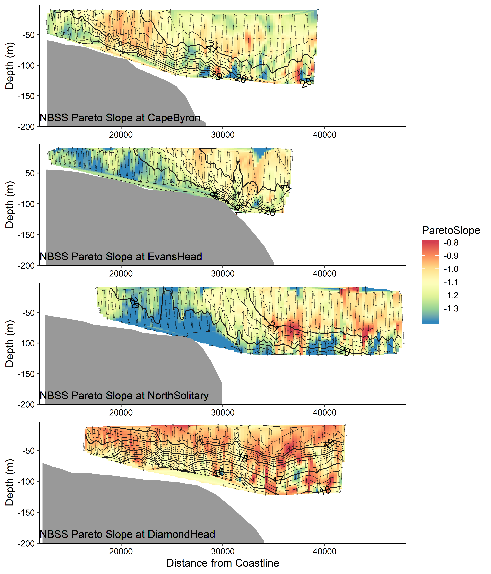

Figure 5. Interpolations of the Normalised Biomass Size Spectrum slope, estimated using the Pareto method from the four cross shelf transects (Figure 1). Transects were conducted form inshore to offshore with an undulating towed body with the path shown by the grey line with midpoints of each sample shown as dots. Temperature (° C) isotherms are shown in black. Note the log transformed colour scale.

Temporal Gradients and Occurrence Rates

The three northern sites which were heavily influenced by the EAC showed strong temperature gradients from inshore to offshore of approximately 1 °C between the cooler inner shelf water and the warmer EAC. In the ten years from 2004 – 2014 this temperature gradient occurred regularly between inshore and offshore waters, reflecting the regular occurrence of the physical mechanisms observed in this study.

On average at our 3 northern sites (cape Byron, Evans Head and North Solitary), there was a mean water temperature difference between inshore water and offshore water of 1.6, 2.1, and 1.9 °C respectively. If the water temperature 5km from shore were used instead, these values changed XXXXX. From 10 years of daily SST data, this 1C temperature gradient was observed at our transect sites, this 1C gradient is observed 23.6, 55.2 and 49.5% of the time at the three northern sites.

Figure 6. Mean percentage of time that a 1 C or greater temperature difference is observed between inshore and offshore waters at the locations of our transects for each month of the year. Error bars show standard deviation and data is based on daily SST measurements from 2004 – 2013.

5 Conclusions

(All figures and tables should be cited in order. For initial submission, please embed figures, tables, and their captions within the main text near where they are cited. At revision, figures should be uploaded separately, as we need separate files for production. Tables and all captions should be moved to the end of the file.)

References should use a name-date format, not numbers. Enclose citations in parentheses with authors in upright text (non italics) as in: (Smith et al*.,* 2009) or Smith et al. (2009). More information on in-text citations can be found in our [Brief Style Guide](https://publications.agu.org/brief-guide-agu-style-grammar/#reference),“Reference Formatting.”

Acknowledgments, Samples, and Data

The text ends with an acknowledgment section and statement that includes:

* Any real or perceived financial conflicts of interests for any author
* Other affiliations for any author that may be perceived as having a conflict of interest with respect to the results of this paper.
* A statement that indicates to the reader where the data supporting the conclusions can be obtained (for example, in the references, tables, supporting information, and other databases).
* Funding information related to the work for all authors should be entered in the form in GEMS as part of your submission. This form in GEMS uses the official Fundref list, which provides a link after publication that is available to funders. Any other funding information not listed in the GEMS form should be included in the acknowledgments and/or cover letter.

It is also the appropriate place to thank colleagues and other contributors. AGU does not normally allow dedications.

AGU supports following [best practices](http://publications.agu.org/author-resource-center/publication-policies/data-policy/data-policy-faq/) and depositing data into domain repositories, or other public repositories. Citations to archived data should be included in your reference list. **Data sets should not be listed as “available from authors.”** Large data sets should ideally be deposited in a domain repository specializing in that data type or a general repository if a specific domain repository is not available. A directory of some Earth and space science repositories is here: <https://copdessdirectory.osf.io/>. Other data should be included as file in supporting information. AGU requires that all data necessary to reproduce the reported finding be available at the time of publication. Further information is available here: <http://publications.agu.org/author-resource-center/publication-policies/data-policy/>

AGU recommends use of [IGSN’s](http://www.igsn.org/) ([**International Geo Sample Numbers**](http://www.geosamples.org/igsnabout)) for citing samples reported in research papers. The IGSN provides a unique identifier that allows samples to be linked across publications and searched through a central metadata repository. We strongly encourage authors to register samples with an [IGSN Allocating Agent](http://www.igsn.org/register-your-samples) and obtain IGSN’s and use them throughout their manuscript, tables, and archived data sets. We recognize IGSN’s during our production process and will provide links in the manuscript and tables to the registered sample descriptions. IGSN’s can be reserved before field seasons, or assigned afterwards. For more information, see <http://www.igsn.org>.

References

References in supporting information should also be cited in the main text and included in the reference list of the main paper so that they will be discovered, linked, and indexed. A separate list in the supporting information is not necessary. References are not included in word counts for excess length fees. Data sets that are not newly reported as part of this research should also be cited in the references as a reference. New data sets or software that are deposited elsewhere with a permanent identifier should be cited. AGU follows the [Joint Declaration of Data Citations Principles.](https://www.force11.org/group/joint-declaration-data-citation-principles-final)

All references must be available to readers at the time of publication; there should be no “unpublished” or “in press” references.

An example of a reference:

Deng, A., & Stauffer, D. R. (2006), On improving 4-km mesoscale model simulations. Journal of Applied Meteorology and Climatology, 45(3), 361–381. doi:10.1175/JAM2341.1

More information on reference formatting with examples can be found in our [Brief Guide to AGU Style](https://publications.agu.org/brief-guide-agu-style-grammar/#reference).

**Figure 1**. The figure caption should begin with an overall descriptive statement of the figure followed by additional text. They should be immediately after each figure. Figure parts are indicated with lower-case letters (**a, b, c…**). For initial submission, please place both the figures and captions in the text near where they are cited rather than at the end of the file (not both). At revision, captions should be placed at the end of the file, and figures should be uploaded separately. Each figure should be one complete file (please do not upload sub-figures in separate files).

**Table 1.** Start this caption with a short description of your table. Format tables using the Word Table commands and structures. Additional information on table formatting can be found in our Style Guide, [Table Formatting](https://publications.agu.org/brief-guide-agu-style-grammar/#tables). Do not create tables using spaces or tabs characters. Large tables especially presenting rich data should be presented as separate excel or .cvs files, not as part of the main text.

Aarflot, J. M., D. L. Aksnes, A. F. Opdal, H. R. Skjoldal, and O. Fiksen (2019), Caught in broad daylight: Topographic constraints of zooplankton depth distributions, *Limnology and Oceanography*, *64*(3), 849-859, doi:10.1002/lno.11079.

Armbrecht, L. H., M. Roughan, V. Rossi, A. Schaeffer, P. L. Davies, A. M. Waite, and L. K. Armand (2014), Phytoplankton composition under contrasting oceanographic conditions: Upwelling and downwelling (Eastern Australia), *Continental Shelf Research*, *75*, 54-67, doi:<https://doi.org/10.1016/j.csr.2013.11.024>.

Armbrecht, L. H., P. A. Thompson, S. W. Wright, A. Schaeffer, M. Roughan, J. Henderiks, and L. K. Armand (2015), Comparison of the cross-shelf phytoplankton distribution of two oceanographically distinct regions off Australia, *J. Mar. Syst.*, *148*, 26-38, doi:10.1016/j.jmarsys.2015.02.002.

Baird, M. E., P. G. Timko, J. H. Middleton, T. J. Mullaney, D. R. Cox, and I. M. Suthers (2008), Biological properties across the Tasman Front off southeast Australia, *Deep-Sea Res. Part I-Oceanogr. Res. Pap.*, *55*(11), 1438-1455, doi:10.1016/j.dsr.2008.06.011.

Barnes, C., D. Maxwell, D. C. Reuman, and S. Jennings (2010), Global patterns in predator–prey size relationships reveal size dependency of trophic transfer efficiency, *Ecology*, *91*(1), 222-232, doi:10.1890/08-2061.1.

Blanchard, J. L., R. F. Heneghan, J. D. Everett, R. Trebilco, and A. J. Richardson (2017), From Bacteria to Whales: Using Functional Size Spectra to Model Marine Ecosystems, *Trends Ecol. Evol.*, *32*(3), 174-186, doi:10.1016/j.tree.2016.12.003.

Cetina-Heredia, P., M. Roughan, E. van Sebille, and M. A. Coleman (2014), Long-term trends in the East Australian Current separation latitude and eddy driven transport, *Journal of Geophysical Research: Oceans*, *119*(7), 4351-4366, doi:10.1002/2014jc010071.

Champion, C., I. M. Suthers, and J. A. Smith (2015), Zooplanktivory is a key process for fish production on a coastal artificial reef, *Marine Ecology Progress Series*, *541*, 1-14, doi:10.3354/meps11529.

GEBCO Bathymetric Compilation Group (2019), The GEBCO_2019 Grid - a continuous terrain model of the global oceans and land., edited by N. O. C. British Oceanographic Data Centre, NERC, UK doi:10/c33m

Herman, A. W. (1992), Design and calibration of a new optical plankton counter capable of sizing small zooplankton, *Deep Sea Research Part A. Oceanographic Research Papers*, *39*(3), 395-415, doi:<https://doi.org/10.1016/0198-0149(92)90080-D>.

Huntley, M. E., A. GonzÃÂ¡lez, Y. Zhu, M. Zhou, and X. Irigoien (2000), Zooplankton dynamics in a mesoscale eddy-jet system off California, *Marine Ecology Progress Series*, *201*, 165-178.

Irigoien, X., J. A. Fernandes, P. Grosjean, K. Denis, A. Albaina, and M. Santos (2008), Spring zooplankton distribution in the Bay of Biscay from 1998 to 2006 in relation with anchovy recruitment, *Journal of Plankton Research*, *31*(1), 1-17, doi:10.1093/plankt/fbn096.

Kerr, S. R., and L. M. Dickie (2001), *The biomass spectrum: a predator-prey theory of aquatic production*, Columbia University Press.

Libralato, S., V. Christensen, and D. Pauly (2006), A method for identifying keystone species in food web models, *Ecological Modelling*, *195*(3), 153-171, doi:<https://doi.org/10.1016/j.ecolmodel.2005.11.029>.

Marcolin, C., R. Lopes, and G. Jackson (2015), Estimating zooplankton vertical distribution from combined LOPC and ZooScan observations on the Brazilian Coast, *Mar. Biol.*, *162*(11), 2171-2186, doi:10.1007/s00227-015-2753-2.

Marcolin, C. d. R., S. Schultes, G. A. Jackson, and R. M. Lopes (2013), Plankton and seston size spectra estimated by the LOPC and ZooScan in the Abrolhos Bank ecosystem (SE Atlantic), *Continental Shelf Research*, *70*, 74-87, doi:<https://doi.org/10.1016/j.csr.2013.09.022>.

Marquis, E., N. Niquil, A. F. Vézina, P. Petitgas, and C. Dupuy (2011), Influence of planktonic foodweb structure on a system's capacity to support pelagic production: an inverse analysis approach, *ICES J. Mar. Sci.*, *68*(5), 803-812, doi:10.1093/icesjms/fsr027.

Oke, P. R., et al. (2019), Revisiting the circulation of the East Australian Current: Its path, separation, and eddy field, *Prog. Oceanogr.*, *176*, 102139, doi:<https://doi.org/10.1016/j.pocean.2019.102139>.

Pereira Brandini, F., M. Nogueira, M. Simião, J. Carlos Ugaz Codina, and M. Almeida Noernberg (2014), Deep chlorophyll maximum and plankton community response to oceanic bottom intrusions on the continental shelf in the South Brazilian Bight, *Continental Shelf Research*, *89*, 61-75, doi:<https://doi.org/10.1016/j.csr.2013.08.002>.

Rossi, V., A. Schaeffer, J. Wood, G. Galibert, B. Morris, J. Sudre, M. Roughan, and A. M. Waite (2014), Seasonality of sporadic physical processes driving temperature and nutrient high-frequency variability in the coastal ocean off southeast Australia, *Journal of Geophysical Research: Oceans*, *119*(1), 445-460, doi:10.1002/2013jc009284.

Roughan, M., H. S. Macdonald, M. E. Baird, and T. M. Glasby (2011), Modelling coastal connectivity in a Western Boundary Current: Seasonal and inter-annual variability, *Deep-Sea Res. Part II-Top. Stud. Oceanogr.*, *58*(5), 628-644, doi:10.1016/j.dsr2.2010.06.004.

Sourisseau, M., and F. Carlotti (2006), Spatial distribution of zooplankton size spectra on the French continental shelf of the Bay of Biscay during spring 2000 and 2001, *Journal of Geophysical Research: Oceans*, *111*(C5), doi:10.1029/2005jc003063.

Truong, L., I. M. Suthers, D. O. Cruz, and J. A. Smith (2017), Plankton supports the majority of fish biomass on temperate rocky reefs, *Mar. Biol.*, *164*(4), 12, doi:10.1007/s00227-017-3101-5.

Turner, J. T., and M. J. Dagg (1983), Vertical Distributions of Continental Shelf Zooplankton in Stratified and Isothermal Waters, *Biological Oceanography*, *3*(1), 1-40, doi:10.1080/01965581.1983.10749470.

Vandromme, P., E. Nogueira, M. Huret, Á. Lopez-Urrutia, G. G.-N. González, M. Sourisseau, and P. Petitgas (2014), Springtime zooplankton size structure over the continental shelf of the Bay of Biscay, *Ocean Science*, *10*, 821-835.